EMTECH FOUNDATION LTD


PRESENTATION ON THE RESULTS FROM THE TRIALS OF EM.1 TECHNOLOGY
Annex 1:

RESULTS FROM AGRICULTURE

Submitted to:
National Biological Control Programme,
P.O.BOX 30031, Kibaha - Tanzania

September 2016

Annex 1A: | Application in Production of Tomatoes
Annex 1B: | Application in Amaranthus – Mchicha
Annex 1C: | Application in Swiss chard
Annex 1D: | Application in Tea
Annex 1E: | Application in Tea
Annex 1F: | Application in Pumpkins
Annex 1G: | Application in Paddy

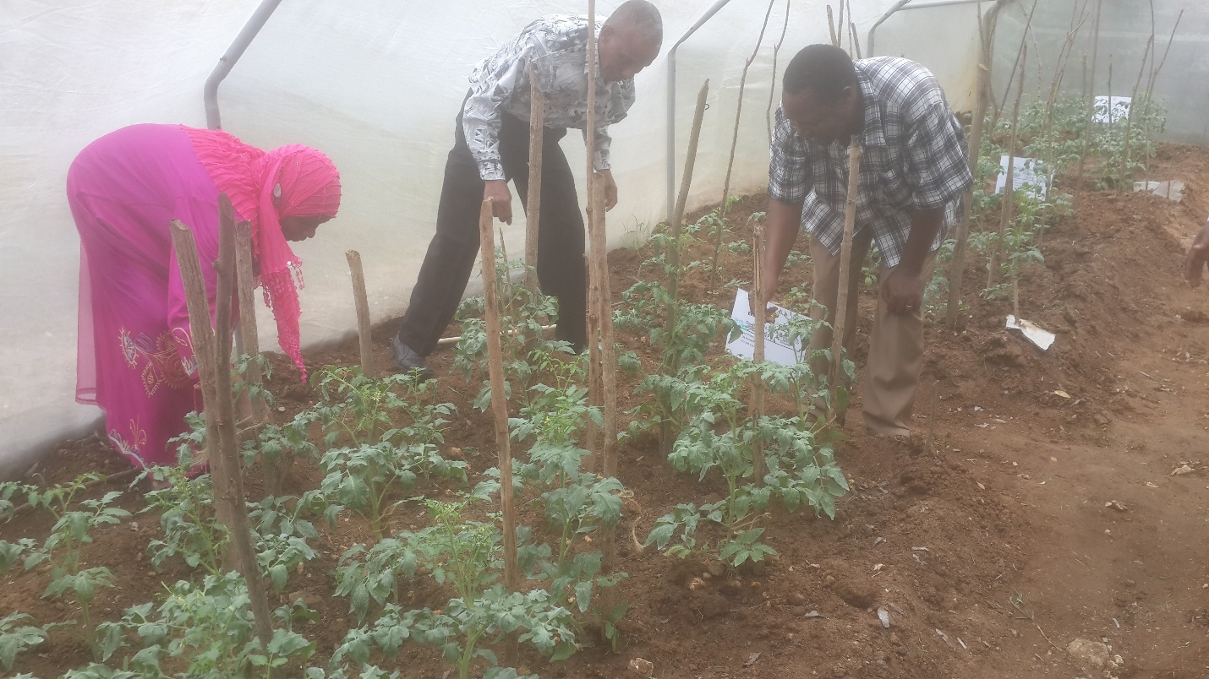
Annex 1A: | Application in Production of Tomatoes

influence of Effective MICROORGANISMS CONSORTIUM on yield and quality nutrients of tomatoes (Lycopersicon esculentum)
ABSTRACT
The use of effective microorganism (EM) consortium along with compost may overcome harmful effects caused by chemical fertilizer on crops production. The study aimed at determining the influence of compost inoculated with EM (EM-compost) on yield and nutrient qualities of tomatoes (Lycopersicon esculentum) grown on tropical loam soil. Four treatment sets were designed; compost without EM (C); compost containing effective microorganisms (EM); compost containing effective microorganisms with chicken manure (CEM) and mineral fertilizer (M). The research was conducted at three sites located at outskirt of Zanzibar Town (Shakani, Dimani and Kiembesamaki), dominantly with loam silt soil
The results showed that the most favorable treatment was compost inoculated with EM by showing yield compared to all treatments. The average increase in yield was 22.24±9.61% and 15.91±5.92% in EM compost and mineral treatments respectively. Similarly, EM consortium revealed a positive effect on improving the nutrients quality of tomatoes. At Shakani research site treatment with EM compost, the level of β-Carotene, Brix, and vitamin C in tomatoes were 7.765µg/100g, 4.9%, 77.55mg/100g compared to of mineral 4.007µg/100g, 4.8%, and 38.83mg/100g respectively. The significance difference in both yield and nutrients qualities with a p-value (p<0.05) were obtained between EM inoculation treatments and the control. Similar results were obtained from research Dimani and Kiembesamaki.
The results demonstrated that both yield and nutrients qualities of tomatoes can improve by inoculating EM consortium through compost as revealed relatively higher yield and augmenting the level of some nutrients. EM compost, therefore, can supersede chemical fertilizer and promote sustainable and environmental friendly tomatoes agriculture
More Details: Video Documentary

Annex 1B: | Application in Amaranthus – Mchicha
 |  | 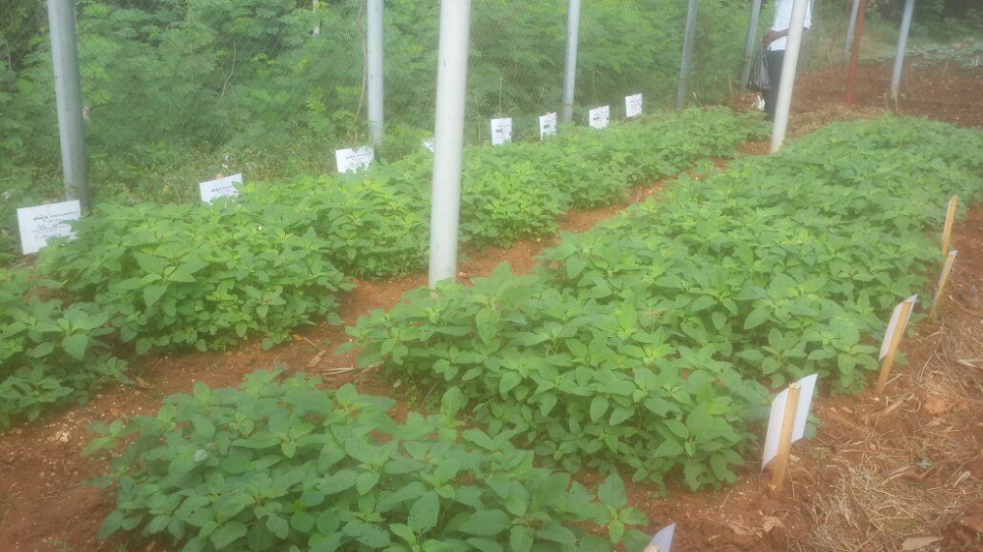

EMTECH FOUNDATION LIMITED
Preliminary Brief Report on the EM Trials to Vegetables
Case of Amaranthus - Mchicha
Date: Sept 2016

Preliminary
A total of six (6) trials with three (3) replica were undertaken to measure the impact on the use of EM.1 technology in the growth and production of Amaranthus– Mchicha. The plot settings were as shown in Table 1. The trials took place at the University of Dar es Salaam plots. The plot sizes were 0.75m x 1.5m. 2.4gm of Amaranthus seeds which are commonly grown by the farmers for commercial use was sowed in each plot – by mixing 100gms of fine sand. The trials sowing was done on 02 June 2016 and the harvest on 1st July 2016.
Table 1: Set up of the Trials.
Plot # | Trial | Plot # | Trial
1 | Control | 10 | Mazao Booster+Emax Bio
2 | EMAx Bio | 11 | Hakika
3 | Mazao Booster | 12 | Hakika + EMAx
4 | Mazao Booster+Emax Bio | 13 | Control
5 | Hakika | 14 | EMAx Bio
6 | Hakika + EMAx | 15 | Mazao Booster
7 | Control | 16 | Mazao Booster+Emax Bio
8 | EMAx Bio | 17 | Hakika
9 | Mazao Booster | 18 | Hakika + EMAx

Explanations:
- Control (CC) = normal cultivation without adding any type of fertilizer. This is normally what a normal farmer could have done
- EMax (EE) = This is a liquid which is made out of EM.1, also known as extended EM.1 with natural addictive. This addictive was named as EMAXTM Bio Liquid. EMAXTM Bio Liquid is made out of water, EM.1 and other natural food substances. A ratio of 10mls litre of EMAXTM Bio Liquid to 5 litres of clean tape water was applied in an irrigation can.
- Mazao Booster (MB) = Mazao Booster is a type of a fermented material made with EM.1 extended (EMAX Bio Liquid), Molasses and Water. This materials is named as FeedproTM Mazao Booster. 200gms of MB was applied to each plot based on this trial.
- Mazao Booster + EMax (MBEE) = A combination of FeedPro Mazao Bookster and EMAX Bio Liquid on the ratios outlined in each individual treatment.
- Hakika (HK) = This is a compost which is commercially available from the market. The details of the compost are as shown in Table 2. The application was based on 1kg per plot.
- Hakika + Emax (HKEE) = Application of Hakika bio fertilizer EMAX Bio Liquid to the rate stated in individual treatments.
During the period of the trial no additional artificial or industrial fertilizer of pesticides were applied.
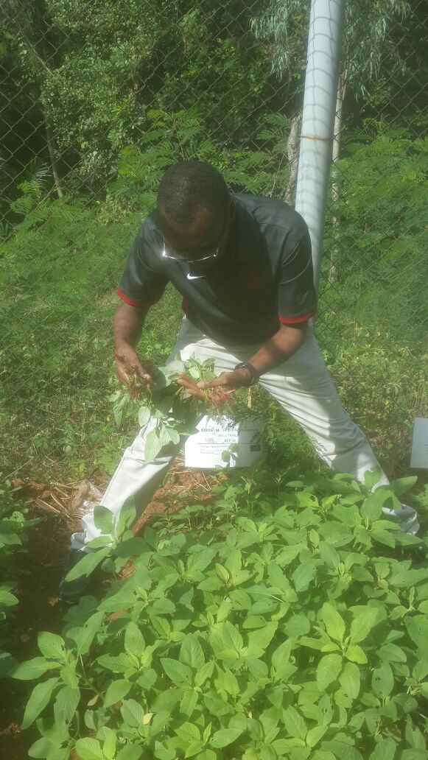

Results

Descriptive Analysis
Measurement was done on three four items of Amaranthus, after it has been harvested in each plot. 12 randomly chosen plants were subject to measurements which included number of leaves, height of the roots and shoots. Weight in Kg was also measured in each of the harvested plot. The descriptive analysis of such measurement is as shown in table 2 and 3 also in figure 1 and 2.
Table 2: Descriptive Analysis of No. of Leaves, Height of Roots and Shoots for the Average Plots
 | N | Minimum | Maximum | Mean | Std. Deviation
CC_leaves | 36 | 8.00 | 15.00 | 11.2 | 1.8
EE_leaves | 36 | 8.00 | 18.00 | 11.9 | 2.3
MB_leaves | 36 | 7.00 | 19.00 | 12.0 | 2.8
MBEE_leaves | 36 | 8.00 | 15.00 | 11.2 | 1.9
HK_leaves | 36 | 8.00 | 17.00 | 12.2 | 1.8
HKEE_leaves | 36 | 9.00 | 16.00 | 11.8 | 1.9
CC_roots | 36 | 4.00 | 17.20 | 9.3 | 2.5
EE_roots | 36 | 5.80 | 23.00 | 10.7 | 3.5
MB_roots | 36 | 5.50 | 15.00 | 9.3 | 2.2
MBEE_roots | 36 | 5.00 | 15.60 | 9.0 | 2.6
HK_roots | 36 | 5.00 | 17.80 | 9.9 | 2.7
HKEE_roots | 36 | 6.00 | 18.00 | 9.8 | 2.6
CC_shoots | 36 | 15.00 | 34.70 | 23.4 | 4.9
EE_shoots | 36 | 6.50 | 38.00 | 24.1 | 6.8
MB_shoots | 36 | 16.00 | 36.00 | 27.0 | 5.9
MBEE_shoots | 36 | 7.50 | 31.00 | 21.4 | 6.5
HK_shoots | 36 | 12.00 | 35.50 | 24.9 | 6.3
HKEE_shoots | 36 | 13.70 | 38.00 | 24.3 | 7.4

Figure 1: Average Number of Leaves and Height of Roots and Shoots

Table 2 and Figure 3 presents descriptive analysis of the number of leaves and the size of the roots and shoots measured in centimetres. The analysis indicated that the maximum number of leaves were form the application of Mazao Booster (MB) with 19 leaves, and an average of 12 ± 2.8 leaves. The mean number of leaves however, were observed from Hakika (HK) – a positive control with 12.2 ± 1.8 leaves followed by the application of the Mazao Booster (MB).
The maximum roots size was on the application of the EMAx Bio Liquid (EE) with 23 cms and the maximum average of 10.7±3.5 cms, followed by the application of Hakika (HK) with an average of 9.9 ± 2.7 cms. The maximum height for the shoots was on the application Mazao Booster (MB) with average of 27± 5.9. Maximum heights were observed in the application of EMAx Bio Liquid (EE) and Application of Hakika and Emax Bio Liquid (HKEE).
Table 3: Summary of the Weight of the Produce in Various Treatments.
Treatment | Weight (Kg) | StdDev | Increase From Control %
Control | 0.98 | 0.46 | -
EMAx Bio | 1.38 | 0.06 | 41%
Mazao Booster | 1.28 | 0.59 | 31%
Mazao Booster+Emax Bio | 1.28 | 0.91 | 31%
Hakika | 1.60 | 0.50 | 63%
Hakika + EMAx | 2.30 | 1.25 | 134%

Maximum average weight was observed in the application of Hakika and EMAx (HKEE) with mean of 2.3±1.25 kg. This was followed by the application of Hakika (HK) with 1.6±0.5 kg and application of EMAx Bio Liquid 1.38±0.06 as presented in table 3 and figure 2. It is also noted that the growth of the plant by 35% and by 44% on the application of EM on the Hakika product.

Figure 2: Weight of the Produce in Various Treatments

Further observation on the number of plots has indicated the following as summarized in table 4.
Table 4: On Field Observation of Various Treatment on the Application of EM in Mchicha plots
Treatment No. | Code | Leaves | Roots
Control - Ve | CC | Few leaves, yellowish in colour | Short roots, many small roots
EMAx Bio | EE | Few leaves but health and greenish | Compact wide at base
Mazao Booster | MB | Very Green and Soft leaves | Long stem, medium sized roots
Mazao Booster+Emax Bio | MBEE | Medium height leaves, green in colour | Wide roots
Positive Control -Hakika | HK | Healthy leaves and green | Widely spread roots
Positive Control + EMAx | HKEE | Few plants long and healthy leaves and soft | Long roots, large stem size

From the descriptive statistics the following can be observed:
- There is significant changes in the application of EM.1 technology in form of secondary products in the growth of the plant.
- On average, application of EM seems to have more impact when applied with organic matter for this case Hakika Bio Fertilizer as noted in Table 3.
- Based on the on the field observations, application of EM especially on the EE seems to create a biological control against pests affecting the leaves of the plants.

Statistical Results
The statistical results were based on the mean comparison analysis of three observed items namely number of leaves, size of roots and shoots in centimetres. For each case a paired sample comparison was based on the control (CC). The sample for each was 12 observations x 3 treatments giving 36 observations in each of the 15 pairwise considerations.

Correlation
A pairwise correlation analysis is as presented in table 5.
Table 5: Paired Samples Correlations
 |  | N | Correlation | Sig.
Pair 1 | CC_leaves & EE_leaves | 36 | -.081 | .637
Pair 2 | CC_leaves & MB_leaves | 36 | -.137 | .424
Pair 3 | CC_leaves & MBEE_leaves | 36 | .155 | .368
Pair 4 | CC_leaves & HK_leaves | 36 | -.005 | .977
Pair 5 | CC_leaves & HKEE_leaves | 36 | .133 | .438
Pair 6 | CC_roots & EE_roots | 36 | -.044 | .798
Pair 7 | CC_roots & MB_roots | 36 | .178 | .300
Pair 8 | CC_roots & MBEE_roots | 36 | -.144 | .403
Pair 9 | CC_roots & HK_roots | 36 | -.380 | .022
Pair 10 | CC_roots & HKEE_roots | 36 | -.311 | .065
Pair 11 | CC_shoots & EE_shoots | 36 | -.335 | .046
Pair 12 | CC_shoots & MB_shoots | 36 | -.059 | .731
Pair 13 | CC_shoots & MBEE_shoots | 36 | .174 | .310
Pair 14 | CC_shoots & HK_shoots | 36 | -.259 | .127
Pair 15 | CC_shoots & HKEE_shoots | 36 | .244 | .152

As noted in table 5, it is observed that there is a negative correlation on the leaves with positives in MBEE and HKEE. The growth of the roots seems to be negative as compared to the control which suggests a good growth of the EM applied plots. The shoots as for the leaves observed a positive. There is a significant relationship based on the application of EM as a liquid, Combination of Hakika and EM and on Hakika vs. control as indicated in Table 5, based on 90% Confidence Interval.

Statistical test
In testing the statistical results we used mean comparison tests.
Table 6: Pairwise Mean Difference on EM Application
 |  | Paired Differences |  |  |  |  | t | df | Sig. (2-tailed)
 |  | Mean | Std. Deviation | Std. Error Mean | 95% Confidence Interval of the Difference |  | t | df | Sig. (2-tailed)
 |  |  |  |  | Lower | Upper | t | df | Sig. (2-tailed)
Pair 1 | CC_leaves - EE_leaves | -.69444 | 2.97436 | .49573 | -1.70082 | .31193 | -1.401 | 35 | .170
Pair 2 | CC_leaves - MB_leaves | -.77778 | 3.53845 | .58974 | -1.97502 | .41946 | -1.319 | 35 | .196
Pair 3 | CC_leaves - MBEE_leaves | .02778 | 2.40815 | .40136 | -.78702 | .84258 | .069 | 35 | .945
Pair 4 | CC_leaves - HK_leaves | -.97222 | 2.53531 | .42255 | -1.83005 | -.11440 | -2.301 | 35 | .027
Pair 5 | CC_leaves - HKEE_leaves | -.58333 | 2.40684 | .40114 | -1.39769 | .23102 | -1.454 | 35 | .155
Pair 6 | CC_roots - EE_roots | -1.43333 | 4.41672 | .73612 | -2.92774 | .06107 | -1.947 | 35 | .060
Pair 7 | CC_roots - MB_roots | 0.00000 | 3.02362 | .50394 | -1.02305 | 1.02305 | 0.000 | 35 | 1.000
Pair 8 | CC_roots - MBEE_roots | .24722 | 3.83327 | .63888 | -1.04977 | 1.54422 | .387 | 35 | .701
Pair 9 | CC_roots - HK_roots | -.62500 | 4.27794 | .71299 | -2.07245 | .82245 | -.877 | 35 | .387
Pair 10 | CC_roots - HKEE_roots | -.46667 | 4.12823 | .68804 | -1.86346 | .93013 | -.678 | 35 | .502
Pair 11 | CC_shoots - EE_shoots | -.69167 | 9.66414 | 1.61069 | -3.96154 | 2.57821 | -.429 | 35 | .670
Pair 12 | CC_shoots - MB_shoots | -3.61389 | 7.88659 | 1.31443 | -6.28233 | -.94545 | -2.749 | 35 | .009
Pair 13 | CC_shoots - MBEE_shoots | 2.06944 | 7.46637 | 1.24440 | -.45681 | 4.59570 | 1.663 | 35 | .105
Pair 14 | CC_shoots - HK_shoots | -1.46111 | 8.97018 | 1.49503 | -4.49618 | 1.57396 | -.977 | 35 | .335
Pair 15 | CC_shoots - HKEE_shoots | -.88333 | 7.80738 | 1.30123 | -3.52497 | 1.75830 | -.679 | 35 | .502

Based on the 90% confidence interval, it can be observed that there is a significant application of Hakika based on the leaves. On the roots, EM application on liquid – i.e. application of EMAx Bio Liquid seems to be significant. On the shoots its can be observed that EM application of the Mazao Booster, i.e. application of Feedpro Mazao Booster is significant. Other details are as observed in table 6.

Conclusion and Similar Studies
The results of the trials concludes that there is significant increase in the productivity of the in the application of EM as irrigation to the mchicha as well as the application of the same as a bio- addictive to organic matter. There is both an increase in the weight by 35% on the application of EM as compared to control. Also when applied on the organic matter, the increase is over 40%. Elsewhere around the world, similar studies which have been done have recorded the same results.



Appendix I: Raw Data
Leaves
CC_leaves | EE_leaves | MB_leaves | MBEE_leaves | HK_leaves | HKEE_leaves
11 | 12 | 13 | 12 | 10 | 15
14 | 10 | 10 | 11 | 13 | 12
11 | 11 | 19 | 11 | 12 | 14
11 | 10 | 11 | 12 | 12 | 15
10 | 10 | 10 | 9 | 11 | 12
11 | 9 | 11 | 12 | 14 | 11
11 | 8 | 15 | 11 | 11 | 11
10 | 10 | 14 | 13 | 12 | 11
10 | 13 | 18 | 11 | 13 | 11
15 | 13 | 15 | 11 | 15 | 12
10 | 13 | 13 | 11 | 11 | 11
14 | 12 | 16 | 11 | 12 | 12
9 | 13 | 9 | 13 | 11 | 12
12 | 12 | 10 | 12 | 15 | 16
11 | 15 | 9 | 11 | 13 | 11
13 | 11 | 9 | 12 | 13 | 14
12 | 10 | 13 | 14 | 8 | 10
11 | 11 | 10 | 11 | 12 | 11
12 | 10 | 7 | 15 | 13 | 11
10 | 10 | 8 | 13 | 10 | 11
11 | 9 | 11 | 15 | 12 | 10
9 | 10 | 11 | 14 | 17 | 9
14 | 10 | 7 | 9 | 11 | 9
14 | 13 | 12 | 15 | 12 | 10
15 | 15 | 11 | 12 | 13 | 15
12 | 15 | 14 | 9 | 11 | 11
8 | 18 | 17 | 9 | 15 | 10
9 | 9 | 11 | 10 | 10 | 12
9 | 15 | 13 | 9 | 15 | 12
11 | 15 | 14 | 10 | 12 | 12
11 | 11 | 12 | 10 | 12 | 12
10 | 13 | 13 | 11 | 12 | 10
10 | 14 | 11 | 9 | 12 | 11
11 | 12 | 12 | 9 | 14 | 15
12 | 13 | 10 | 8 | 10 | 9
10 | 14 | 13 | 8 | 10 | 15

Roots
CC_roots | EE_roots | MB_roots | MBEE_roots | HK_roots | HKEE_roots
7.2 | 8.5 | 9 | 8.7 | 14 | 11.5
12.5 | 6 | 12 | 15 | 11.7 | 8
17.2 | 7.2 | 12 | 9.3 | 7.9 | 7
10 | 7.5 | 14 | 11 | 11.5 | 11.5
7.2 | 9.5 | 7.5 | 11 | 7.5 | 7.8
5 | 8 | 6.5 | 9.2 | 15 | 12
8.2 | 7.5 | 10 | 15 | 17.8 | 18
4 | 11 | 13 | 15.6 | 15.2 | 8
12 | 11 | 11 | 7 | 11.2 | 12
8.5 | 8.5 | 13 | 9.2 | 9.2 | 6
7.9 | 5.8 | 15 | 8 | 10 | 14.4
12 | 12.3 | 9 | 10.1 | 11 | 7
12 | 11.5 | 9 | 8 | 6.2 | 9
8 | 8 | 7.5 | 7.5 | 8.1 | 14
8 | 12 | 8 | 7 | 9 | 9.2
10 | 14 | 7.5 | 8 | 8.5 | 9.5
9 | 14 | 9 | 6.2 | 10 | 8.5
9.5 | 6.5 | 9.1 | 5 | 9 | 8
13 | 9.5 | 7 | 8 | 9 | 7.5
9 | 9.5 | 6.4 | 8 | 7 | 9.4
8.5 | 7 | 8 | 11 | 7 | 11
9 | 12 | 5.5 | 7 | 8.2 | 14.5
13 | 10 | 11 | 12 | 5 | 7
9 | 9 | 10.5 | 9 | 6.5 | 8.5
7 | 12 | 7.5 | 8 | 8.5 | 11
10 | 18 | 9 | 8.5 | 8.5 | 9
9 | 23 | 9.5 | 6 | 10 | 9
7 | 12 | 8.5 | 9 | 10.4 | 9.7
8 | 12 | 8.5 | 7 | 10 | 10.5
10 | 17 | 8.5 | 7 | 10.5 | 6.5
11 | 12 | 10 | 8 | 10.5 | 8.5
6.5 | 14 | 10 | 12 | 9.8 | 9
10 | 11 | 10 | 6.5 | 11 | 12.5
7 | 9 | 7.5 | 12.5 | 12 | 9.5
10 | 11 | 7.7 | 8 | 12 | 9.5
9 | 9 | 7 | 7 | 8 | 7

Shoots
CC_shoots | EE_shoots | MB_shoots | MBEE_shoots | HK_shoots | HKEE_shoots
19.5 | 31 | 17 | 30 | 17.5 | 31.5
32 | 25.3 | 23 | 24 | 22.7 | 18.5
21 | 23.5 | 33 | 23 | 25.5 | 27.5
29 | 21.5 | 23 | 29 | 12 | 29
22 | 23.5 | 25 | 20 | 30 | 16.5
15 | 23 | 23 | 30 | 32.5 | 16
33 | 6.5 | 30 | 25 | 29.8 | 17
18.5 | 15 | 30 | 28 | 29.5 | 16.5
17.2 | 21 | 36 | 30 | 14 | 14.5
34.7 | 26.5 | 33 | 30 | 28.5 | 22
27.5 | 8.5 | 30 | 20 | 28.2 | 13.7
26 | 21 | 34 | 31 | 26 | 21
26 | 30 | 31 | 18 | 23 | 37.5
24 | 24 | 27.8 | 15.7 | 27.5 | 38
26 | 30 | 24.5 | 28 | 23.5 | 36.5
30 | 20 | 19 | 27 | 18.5 | 36
25 | 20 | 30 | 25.7 | 12.5 | 33
29 | 20 | 18.5 | 22 | 24.5 | 28
19 | 20 | 16 | 21 | 18.5 | 33.5
26 | 15 | 18.5 | 7.5 | 21.5 | 30
20 | 16 | 34 | 31 | 19.5 | 20
28 | 23 | 30 | 27 | 15.6 | 30
27 | 20 | 32.5 | 19 | 23.2 | 33
20 | 25 | 27.5 | 24 | 24.5 | 19
24 | 30 | 32 | 14 | 23.5 | 21
21 | 35 | 36 | 12 | 27 | 17.5
21 | 38 | 21 | 13 | 31 | 16
19 | 22 | 27.5 | 17 | 26 | 17.5
17 | 30 | 29 | 14 | 33 | 27
21 | 31 | 25 | 16 | 33.5 | 26.5
18 | 30 | 31 | 16 | 33 | 21
18 | 31 | 34 | 19 | 35.5 | 18
19 | 32 | 19 | 18 | 33 | 21.5
24 | 25 | 21.2 | 18 | 31.5 | 26
25 | 30 | 20 | 13 | 23 | 17
21 | 25 | 31.5 | 13 | 17.5 | 28

MCHICHA ULILIMWA KWA KUTUMIA BIDHAA YA EM (FEEDPRO MAZAO BOOSTER)
Eneo: Ruvu Station, Pwani. Majira: May – June 2015
Eneo: Kibamba kwa Obama, Dar es Salaam. Majira : July -August 2016

Muhtasari:
Jaribio la kwanza tumelima mchicha Ruvu Station chini ya kikundi cha uvumbuzi, matuta 10 yote yaliwekwa mbolea ya samadi lakini tulichagua matuta 2 ambayo tuliweka EM ambayo ni FeedPro Mazao Booster. Mchicha wote uliota vizuri kwa matuta yote, lakini katika hatua ya ukuaji matuta ya EM yalistawi vizuri na yakawa ya kwanza kuvunwa kabla ya matuta mengine.matuta yaliowekewa EM yalivutia sana wateja wetu mpaka kuulizia tena mchicha huo, kwani waliusifu ulikua mlaini na ni mtamu sana kuliko mingine ambayo inalimwa kwa chumvichumvi.
Hatua tulizotumia kuandaa tuta la kuwekea EM; tulichimba mtaro katikati ya tuta kisha tukajaza mabaki ya mazao yaliokwisha vunwa, tukayaloweka na EM kwa muda kisha tukafunika na mbolea na udongo. Baada ya hapo tukaweka Feedpro Mazao Booster, ambayo ni bidhaa endelevu ya EM. Hivyo tukathibitisha kwamba mkulima akiandaa shamba lake vizuri kwa kutumia EM atavuna mchicha wake kwa muda wa siku 18.
Jaribio la Pili
JAribio hili lilifanyika Kibamba kwa Mangi, Dar es Salaam. Tuliandaa shamba la mita 1 kwa mita 10 tukaweka matuta 6 ya zao la mchicha pia hapa tukachagua matuta mawili tukayaweka EM Feedpro Mazao Booster kiasi cha kilo mbili na nusu kwa tuta la mita 1 kwa mita 10 matokeo yamekua mazuri kama yale ya mwanzo, pia katika matuta yaliyowekewa kichocheo cha EM tofauti yake ilikua futi 2 urefu kati ya ule wa EM na ule ambao hatujaweka. Mchicha ulipandwa tarehe 8 August 2016 ukavunwa tarehe 22 August jumla ya siku 14.
Jinsi tulivyo andaa shamba ni kama mwanzo lakini hapa tukaweka samadi ndoo 25 kila tuta lakini kwa ya EM tukaongeza hapo Mazao Booster kiasi cha kilo 2.5 kila tuta la mita 1 kwa 10.
Matokeo: Mchanganyiko huu hupunguza gharama, huhifadhi ardhi na kuleta matokeo bora zaidi kwenye uzalishaji hasa kwa wakulima wadogo na wananchi wa kipato cha chini. Kinachotakiwa ni mkulima kutumia samadi kwenye shamba lake.
Mkulima: Nicolaus Byetuka. Simu:

EMTECH FOUNDATION LIMITED
Changanyikeni, Dar es Salaam
P. O. Box 110136, Dar es Salaam
Email: emtanzania@gmail.com
Simu: +255 75 6446 468 / 075 4300 495

Annex 1C: | Application in Swiss chard
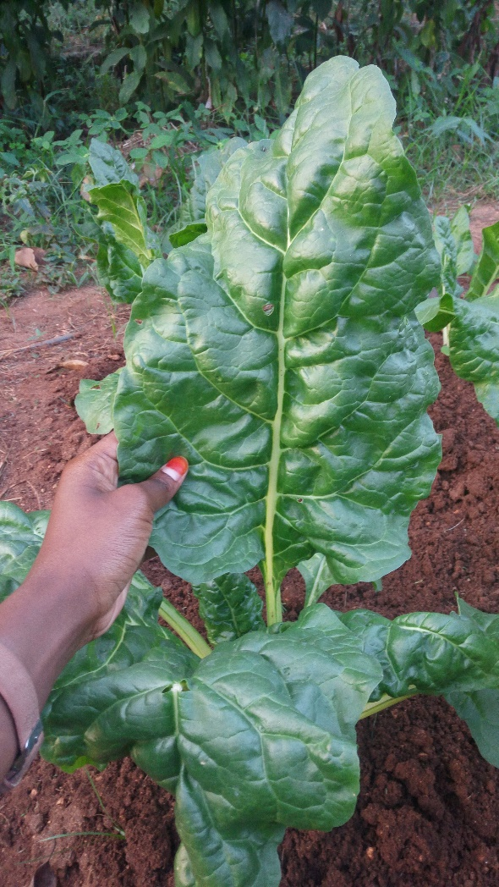 | 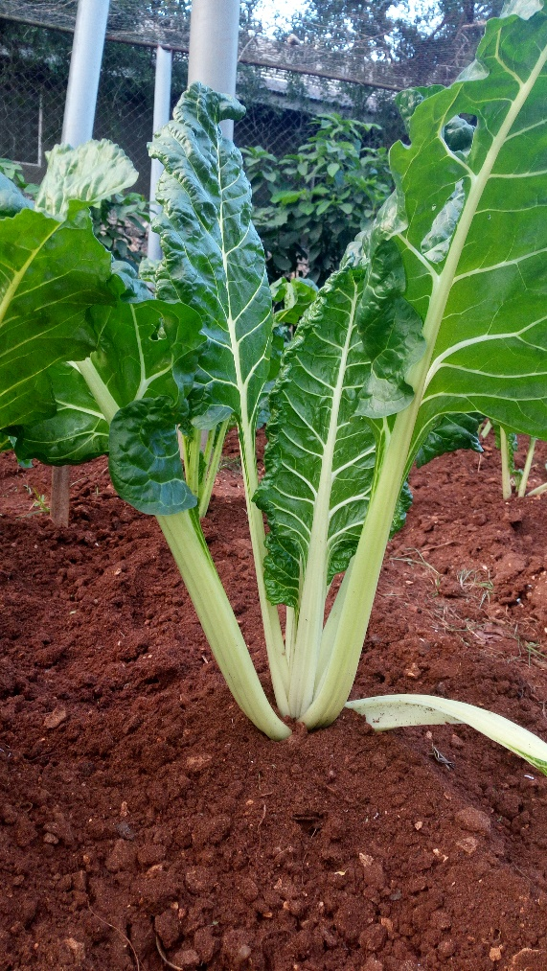

EMTECH FOUNDATION LIMITED
Preliminary Brief Report on the EM Trials to Vegetables
Case of Swiss chard
Date: Sept 2016

Preliminary
A total of six (6) trials with three (3) replica were undertaken to measure the impact on the use of EM.1 technology in the growth and production of Swiss chard. The plot settings were as shown in Table 1. The trials took place at the University of Dar es Salaam plots. The plot sizes were 0.75m x 1.5m. Six (6) plants were planted in each plot. The planting of the Swiss chard was done on 20th June 2016 and the harvest on 26th August 2016.
Table 7: Set up of the Trials.
Plot # | Trial | Plot # | Trial
1 | Control | 10 | Mazao Booster+Emax Bio
2 | EMAx Bio | 11 | Hakika
3 | Mazao Booster | 12 | Hakika + EMAx
4 | Mazao Booster+Emax Bio | 13 | Control
5 | Hakika | 14 | EMAx Bio
6 | Hakika + EMAx | 15 | Mazao Booster
7 | Control | 16 | Mazao Booster+Emax Bio
8 | EMAx Bio | 17 | Hakika
9 | Mazao Booster | 18 | Hakika + EMAx
Explanations:
- Control (CC) = normal cultivation without adding any type of fertilizer. This is normally what a normal farmer could have done
- EMax (EE) = This is a liquid which is made out of EM.1, also known as extended EM.1 with natural addictive. This addictive was named as EMAXTM Bio Liquid. EMAXTM Bio Liquid is made out of water, EM.1 and other natural food substances. A ratio of 10mls litre of EMAXTM Bio Liquid to 5 litres of clean tape water was applied in an irrigation can.
- Mazao Booster (MB) = Mazao Booster is a type of a fermented material made with EM.1 extended (EMAX Bio Liquid), Molasses and Water. This materials is named as FeedproTM Mazao Booster. 200gms of MB was applied to each plot based on this trial.
- Mazao Booster + EMax (MBEE) = A combination of FeedPro Mazao Bookster and EMAX Bio Liquid on the ratios outlined in each individual treatment.
- Hakika (HK) = This is a compost which is commercially available from the market. The details of the compost are as shown in Table 2. The application was based on 1kg per plot.
- Hakika + Emax (HKEE) = Application of Hakika bio fertilizer EMAX Bio Liquid to the rate stated in individual treatments.
During the period of the trial no additional artificial or industrial fertilizer of pesticides were applied.

Results

Descriptive Analysis

Measurement was done on four parameters of Swiss chard, after it has been harvested in each plot. Three randomly chosen plants were subject to measurements which included number of leaves, height of the roots and shoots. Weight in Kg was also measured in each of the harvested plot. The descriptive analysis of such measurement is as shown in table 2 and 3 also in figure 1 and 2.
Table 8: Descriptive Analysis of No. of Leaves, Height of Roots and Shoots for the Average Plots
Description | N | Minimum | Maximum | Mean | Std. Deviation
CC_Roots | 9 | 15.00 | 32.00 | 20.8 | 5.2
EE_Roots | 9 | 13.00 | 34.00 | 21.1 | 6.1
MB_Roots | 9 | 17.00 | 35.00 | 23.9 | 5.2
MBEE_Roots | 9 | 11.00 | 27.00 | 19.1 | 5.2
HK_Roots | 9 | 10.00 | 27.00 | 19.3 | 5.8
HKEE_Roots | 9 | 13.00 | 37.00 | 23.9 | 7.7
CC_LWidth | 9 | 13.00 | 19.00 | 16.2 | 1.9
EE_LWidth | 9 | 17.00 | 22.00 | 18.7 | 1.9
MB_LWidth | 9 | 12.00 | 26.00 | 19.8 | 4.2
MBEE_LWidth | 9 | 16.00 | 24.00 | 18.0 | 2.7
HK_LWidth | 9 | 13.00 | 22.00 | 18.3 | 3.1
HKEE_LWidth | 9 | 17.00 | 25.00 | 19.9 | 2.3
CC_Lheight | 9 | 35.00 | 51.00 | 44.2 | 5.1
EE_Lheight | 9 | 43.00 | 60.00 | 52.1 | 5.8
MB_Lheight | 9 | 45.00 | 67.00 | 57.0 | 7.0
MBEE_Lheight | 9 | 43.00 | 60.00 | 51.1 | 5.9
HK_Lheight | 9 | 21.00 | 62.00 | 48.3 | 12.0
HKEE_Lheight | 9 | 48.00 | 62.00 | 54.1 | 4.0
Valid N (listwise) | 9

The maximum roots size was on the application of the Hakika and EMAx Bio Liquid (HKEE) with 37 cms and the maximum average of 23.9±7.7 cms, followed by the application of FeedPro Mazao Booster (MB) 35cm with same average as HKEE, followed by application of EMAx Bio Liquid (EE) with an average of 21.1 ± 6.1 cms. The maximum leave width was observed in the application of MB 26cms, average 19.8±4.2 cms. Length of the leavers were recorded highest in the application of MB 67cm with average height of 57 ± 7 cms followed by HKEE and EE with both with 62 cms. On average, second place was for HKEE application with 54.1±4 cm.
Figure 1: Average Number of Leaves and Weight of the Swiss chard

Figure 1 and Table 3 presents descriptive analysis of the number of leaves and the number of leaves in each plot size in average based on the six replica plots. The analysis indicated that the maximum average number of leaves were based the application of Mazao Booster (MB) with 46.7 ±4 leaves followed by application of Hakika (HK) with average leaves of 46±9.5.
Table 9: Summary of the Weight and Number of Leaves of Swiss chard in Various Treatments.
Treatment | Wt. (Kg) | StdDev | Difference | No. Leaves | StdDev | Difference
Control | 0.75 | 0.1 | 0.0% | 40.3 | 4.2
Emax Bio | 0.98 | 0.3 | 31.1% | 43.3 | 6.5 | 7.4%
Hakika | 0.93 | 0.3 | 24.4% | 46.0 | 9.5 | 14.0%
Hakika Emax Bio | 1.17 | 0.1 | 55.6% | 44.3 | 8.3 | 9.9%
Mazao Booster | 1.10 | 0.1 | 46.7% | 46.7 | 4.0 | 15.7%
Mazao Booster + EMAX Bio | 0.97 | 0.4 | 28.9% | 42.3 | 15.0 | 5.0%

Maximum average weight was observed in the application of Hakika and EMAx Bio Liquid (HKEE) with mean of 1.17±0.1 kg. This was followed by the application of Feedpro Mazao Booster (MB) with 1.10±0.1 kg and application of EMAx Bio Liquid (EE) 0.98±0.3 as presented in figure 1. It is also noted that the growth of the plant by 35.8% and by 26% on the application of EM on the Hakika product.
Further observation on the number of plots has indicated the following as summarized in table 4.
Table 10: On Field Observation of Various Treatment on the Application of EM in Swiss chard plots
Treatment No. | Code | Leaves
Control - Ve | CC | Short and few leaves, yellowish in colour
EMAx Bio | EE | Long leaves and greenish, Leaves
Mazao Booster | MB | Long and very green leaves, many leaves
Mazao Booster+Emax Bio | MBEE | Many leaves, long and green in colour
Positive Control -Hakika | HK | Medium height leaves and green
Positive Control + EMAx | HKEE | medium and healthy leaves and green

From the descriptive statistics the following can be observed:
- Roots: Strongest positive effect on roots length is seen with Mazao Booster and Hakika+EmaxBio treatments when compared to control. This is saying, Mazao Booster and EmaxBio used with organic fertilizer promote root development in swisschard, which may help the plants to get more water and nutrients for growth.
- Leaves width: All treatments gave wider leaves than control plants, with more increase on the width of the leaves being observed on Feedpro Mazao Booster, EmaxBio, Hakika+EmaxBio and Mazao Booster+EmaxBio Treatments
- Height: All treatments values are higher than control, especially with FeedPro Mazao booster, EmaxBio, Hakika+EmaxBio and Mazao Booster+EmaxBio Treatments
Further,
- There is significant changes in the application of EM.1 technology in form of secondary products in the growth of the plant.
- On average, application of EM seems to have more impact when applied with organic matter for this case Hakika Bio Fertilizer as noted in Table 3.
- Based on the on the field observations, application of EM especially on the EE seems to create a biological control against pests affecting the leaves of the plants.

Statistical Results
The statistical results were based on the mean comparison analysis of three observed items namely number of leaves, size of roots and shoots in centimetres. For each case a paired sample comparison was based on the control (CC). The sample for each was 3 observations x 3 treatments giving 9 observations in each of the 15 pairwise considerations.

Correlation
A pairwise correlation analysis is as presented in table 5.
Table 11: Paired Samples Correlations
Description |  | N | Correlation | Sig.
Pair 1 | CC_Roots & EE_Roots | 9 | .036 | .926
Pair 2 | CC_Roots & MB_Roots | 9 | -.253 | .511
Pair 3 | CC_Roots & MBEE_Roots | 9 | -.146 | .707
Pair 4 | CC_Roots & HK_Roots | 9 | -.385 | .307
Pair 5 | CC_Roots & HKEE_Roots | 9 | -.368 | .330
Pair 6 | CC_LWidth & EE_LWidth | 9 | .333 | .381
Pair 7 | CC_LWidth & MB_LWidth | 9 | -.686 | .041
Pair 8 | CC_LWidth & MBEE_LWidth | 9 | -.707 | .033
Pair 9 | CC_LWidth & HK_LWidth | 9 | .242 | .531
Pair 10 | CC_LWidth & HKEE_LWidth | 9 | .302 | .429
Pair 11 | CC_Lheight & EE_Lheight | 9 | -.608 | .083
Pair 12 | CC_Lheight & MB_Lheight | 9 | -.056 | .887
Pair 13 | CC_Lheight & MBEE_Lheight | 9 | -.254 | .509
Pair 14 | CC_Lheight & HK_Lheight | 9 | -.068 | .861
Pair 15 | CC_Lheight & HKEE_Lheight | 9 | .240 | .534
As noted in table 5, it is observed that there is a negative correlation on the leaves with positives in MBEE and HKEE. The growth of the roots seems to be negative as compared to the control which suggests a good growth of the EM applied plots. The shoots as for the leaves observed a positive. There is a significant relationship based on the application of EM as a liquid, Combination of Hakika and EM and on Hakika vs. control as indicated in Table 5, based on 90% Confidence Interval.

Statistical test
In testing the statistical results we used mean comparison tests.
Table 12: Pairwise Mean Difference on EM Application
Description |  | Paired Differences |  |  |  |  | t | df | Sig. (2-tailed)
 |  | Mean | Std. Deviation | Std. Error Mean | 90% Confidence Interval of the Difference |  | t | df | Sig. (2-tailed)
 |  |  |  |  | Lower | Upper | t | df | Sig. (2-tailed)
Pair 1 | CC_Roots - EE_Roots | -0.33 | 7.86 | 2.62 | -5.20 | 4.54 | -0.13 | 8 | .902
Pair 2 | CC_Roots - MB_Roots | -3.11 | 8.27 | 2.76 | -8.24 | 2.01 | -1.13 | 8 | .292
Pair 3 | CC_Roots - MBEE_Roots | 1.67 | 7.89 | 2.63 | -3.22 | 6.56 | 0.63 | 8 | .544
Pair 4 | CC_Roots - HK_Roots | 1.44 | 9.18 | 3.06 | -4.25 | 7.13 | 0.47 | 8 | .650
Pair 5 | CC_Roots - HKEE_Roots | -3.11 | 10.76 | 3.59 | -9.78 | 3.56 | -0.87 | 8 | .411
Pair 6 | CC_LWidth - EE_LWidth | -2.50 | 2.18 | 0.73 | -3.85 | -1.15 | -3.44 | 8 | .009
Pair 7 | CC_LWidth - MB_LWidth | -3.61 | 5.66 | 1.89 | -7.12 | -0.11 | -1.92 | 8 | .092
Pair 8 | CC_LWidth - MBEE_LWidth | -1.83 | 4.26 | 1.42 | -4.47 | 0.81 | -1.29 | 8 | .232
Pair 9 | CC_LWidth - HK_LWidth | -2.17 | 3.24 | 1.08 | -4.18 | -0.16 | -2.01 | 8 | .080
Pair 10 | CC_LWidth - HKEE_LWidth | -3.72 | 2.51 | 0.84 | -5.28 | -2.16 | -4.44 | 8 | .002
Pair 11 | CC_Lheight - EE_Lheight | -7.89 | 9.79 | 3.26 | -13.96 | -1.82 | -2.42 | 8 | .042
Pair 12 | CC_Lheight - MB_Lheight | -12.78 | 8.93 | 2.98 | -18.31 | -7.24 | -4.29 | 8 | .003
Pair 13 | CC_Lheight - MBEE_Lheight | -6.89 | 8.72 | 2.91 | -12.30 | -1.48 | -2.37 | 8 | .045
Pair 14 | CC_Lheight - HK_Lheight | -4.11 | 13.40 | 4.47 | -12.42 | 4.20 | -0.92 | 8 | .384
Pair 15 | CC_Lheight - HKEE_Lheight | -9.89 | 5.71 | 1.90 | -13.43 | -6.35 | -5.20 | 8 | .001

Based on the 90% confidence interval, it can be observed that there is a significant effect on the application of EM to leaves width and height. Based on the height – application of Hakika - A well industrial prepared compost shows no significant to the control. Also application of MBEE was not significant for the width of the leaves. No significant differences were recorded on the roots. Further details are as observed in table 6.

Conclusion and Similar Studies

The results of the trials concludes that there is significant increase in the productivity of the in the application of EM as irrigation to the Swiss chard as well as the application of the same as a bio- addictive to organic matter. There is both an increase in the weight by 35% on the application of EM as compared to control. Also when applied on the organic matter, the increase is over 40%. Elsewhere around the world, similar studies which have been done have recorded the same results.
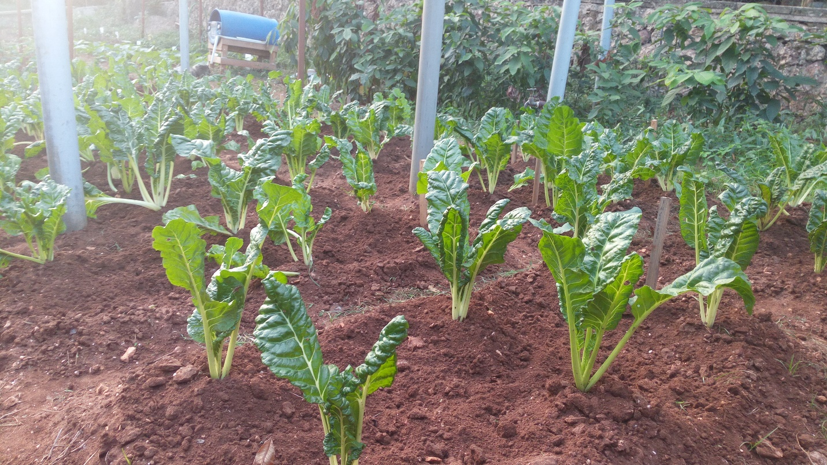

Appendix I: Raw Data
Treatment/Obsv> | 1 | 2 | 3 | 4 | 5 | 6 | 7 | 8 | 9
CC_Roots | 32 | 18 | 16 | 23 | 15 | 24 | 21 | 17 | 21
EE_Roots | 17 | 22 | 16 | 34 | 23 | 24 | 22 | 19 | 13
MB_Roots | 17 | 25 | 19 | 24 | 25 | 26 | 35 | 24 | 20
MBEE_Roots | 24 | 24 | 27 | 14 | 18 | 11 | 18 | 20 | 16
HK_Roots | 15 | 21 | 10 | 20 | 27 | 14 | 24 | 26 | 17
HKEE_Roots | 21 | 21 | 37 | 18 | 22 | 13 | 35 | 23 | 25
CC_LWidth | 14 | 17 | 18 | 19 | 16 | 16.5 | 17 | 15 | 13
EE_LWidth | 17 | 17 | 17 | 21 | 19 | 19 | 22 | 17 | 19
MB_LWidth | 26 | 15 | 12 | 19 | 21 | 22 | 20 | 20 | 23
MBEE_LWidth | 24 | 19 | 16 | 16 | 18 | 16 | 16 | 17 | 20
HK_LWidth | 18 | 20 | 13 | 21 | 17 | 20 | 20 | 22 | 14
HKEE_LWidth | 17 | 22 | 19 | 19 | 19 | 19 | 25 | 20 | 19
CC_Lheight | 44 | 46 | 48 | 40 | 42 | 51 | 50 | 42 | 35
EE_Lheight | 51 | 43 | 45 | 60 | 51 | 54 | 51 | 54 | 60
MB_Lheight | 60 | 47 | 45 | 62 | 55 | 67 | 60 | 58 | 59
MBEE_Lheight | 53 | 52 | 49 | 47 | 46 | 43 | 60 | 50 | 60
HK_Lheight | 48 | 21 | 43 | 57 | 49 | 59 | 50 | 62 | 46
HKEE_Lheight | 56 | 62 | 55 | 55 | 48 | 52 | 53 | 56 | 50

Annex 1D: | Application in Production of Sweet Peppers

EMTECH FOUNDATION LIMITED
Preliminary Brief Report on the EM Trials to Vegetables
Case of Sweet Peppers
Date: Sept 2016

Preliminary
A A total of six (6) trials with three (3) replica were undertaken to measure the impact on the use of EM.1 technology in the growth and production of Sweet peppers. The plot settings were as shown in Table 1. The trials took place at the University of Dar es Salaam plots – an ongoing as of 25th Sep 2016. The plot sizes were 0.75m x 1.5m. Six (6) plants were planted in each plot. The planting of the Sweet Peppers was done on _____________
Table 1: Set up of the Trials.
Plot # | Trial | Plot # | Trial
1 | Control | 10 | Mazao Booster+Emax Bio
2 | EMAx Bio | 11 | Hakika
3 | Mazao Booster | 12 | Hakika + EMAx
4 | Mazao Booster+Emax Bio | 13 | Control
5 | Hakika | 14 | EMAx Bio
6 | Hakika + EMAx | 15 | Mazao Booster
7 | Contro | 16 | Mazao Booster+Emax Bio
8 | EMAx Bio | 17 | Hakika
9 | Mazao Booster | 18 | Hakika + EMAx

Explanations:
- Control (CC) = normal cultivation without adding any type of fertlizer. This is normally what a normal farmer could have done
- EMax (EE) = This is a liquid which is made out of EM.1, also known as extended EM.1 with natural addictive. This addictive was named as EMAXTM Bio Liquid. EMAXTM Bio Liquid is made out of water, EM.1 and other natural food substances. A ratio of 10mls liter of EMAXTM Bio Liquid to 5 litres of clean tape water was applied in an irrigation can.
- Mazao Booster (MB) = Mazao Booster is a type of a fermented material made with EM.1 extended (EMAX Bio Liquid), Molasses and Water. This materials is named as FeedproTM Mazao Booster. 200gms of MB was applied to each plot based on this trial.
- Mazao Booster + EMax (MBEE) = A combination of FeedPro Mazao Bookster and EMAX Bio Liquid on the ratios outlined in each individual treatment.
- Hakika (HK) = This is a composit which is commercially available from the market. The details of the compost are as shown in Table 2. The application was based on 1kg per plot.
- Hakika + Emax (HKEE) = Application of Hakika bio fertilizer EMAX Bio Liquid to the rate stated in individual treatments.
During the period of the trial no additional artificial or industrial fertilizer of pesticides were applied.

Results

Descriptive Analysis

Measurement was done on three parameters of Sweet Peppers, after it has been harvested in each plot. Three randomly chosen plants were subject to measurements which included number of flowers, height of the shoots and the number of fruits . Weight in Kg was also measured in each of the harvested plot. The descriptive analysis of such measurement is as shown in table 2 and 3 also in figure 1 and 2.
Table 2: Descriptive Analysis of No. of Fruits and Flowers and Height of Shoots for the Average Plots
 | N | Minimum | Maximum | Mean | Std. Deviation
CC_height | 9 | 20.00 | 34.00 | 26.6667 | 4.74342
EE_height | 9 | 19.00 | 41.00 | 30.5556 | 8.00174
MB_height | 9 | 19.00 | 44.00 | 27.7222 | 7.17248
MBEE_height | 9 | 25.00 | 42.00 | 33.8889 | 5.98841
HK_height | 9 | 20.00 | 42.00 | 28.5556 | 7.46845
HKEE_height | 9 | 17.00 | 49.00 | 37.6667 | 10.79352
CC_Nflowers | 9 | 2.00 | 9.00 | 5.3333 | 2.69258
EE_Nflowers | 9 | 6.00 | 10.00 | 8.0000 | 1.58114
MB_Nflowers | 9 | .00 | 12.00 | 4.5556 | 4.53076
MBEE_Nflowers | 9 | 6.00 | 17.00 | 10.7778 | 3.73423
HK_Nflowers | 9 | 6.00 | 16.00 | 9.5556 | 3.12694
HKEE_Nflowers | 9 | 7.00 | 16.00 | 11.2222 | 3.15348
CC_Nfruits | 9 | .00 | 3.00 | 1.1111 | .92796
EE_Nfruits | 9 | 1.00 | 5.00 | 2.5556 | 1.33333
MB_Nfruits | 9 | .00 | 5.00 | 2.1111 | 1.61589
MBEE_Nfruits | 9 | 1.00 | 8.00 | 4.4444 | 2.50555
HK_Nfruits | 9 | 1.00 | 6.00 | 2.4444 | 1.87824
HKEE_Nfruits | 9 | 1.00 | 7.00 | 3.6667 | 2.23607
Valid N (listwise) | 9

- Height of Shoots: Strongest positive effect on roots length is seen with Hakika+EmaxBio treatments when compared to control and secondly with Mazao Booster and EmaxBio used with organic fertilizer promote root development in Sweet Peppers, that may help the plants to get more water and nutrients for growth.
- Number of Flowers: are more feasible in application with Feedpro Mazao Booster + EmaxBio followed by Hakika+EmaxBio
- Number of Fruits: are more feasible in application with Feedpro Mazao Booster + EmaxBio followed by Hakika+EmaxBio

Figure 2-1: Average Number of Flowers and Fruits Sweet Peppers

Figure 2-2Average Height of Shoots of Sweet Peppers

Statistical Results
The statistical results were based on the mean comparison analysis of three observed items namely number of leaves, size of roots and shoots in centimeters. For each case a paired sample comparison was based on the control (CC). The sample for each was 3 observations x 3 treatments giving 9 observations in each of the 15 pairwise considerations.

Correlation
A pairwise correlation analysis is as presented in table 3.
Table 3: Paired Samples Correlations
 |  | N | Correlation | Sig.
Pair 1 | CC_height & EE_height | 9 | .684 | .042
Pair 2 | CC_height & MB_height | 9 | .177 | .649
Pair 3 | CC_height & MBEE_height | 9 | -.094 | .810
Pair 4 | CC_height & HK_height | 9 | -.195 | .615
Pair 5 | CC_height & HKEE_height | 9 | -.625 | .072
Pair 6 | CC_Nflowers & EE_Nflowers | 9 | .323 | .397
Pair 7 | CC_Nflowers & MB_Nflowers | 9 | .003 | .993
Pair 8 | CC_Nflowers & MBEE_Nflowers | 9 | .021 | .958
Pair 9 | CC_Nflowers & HK_Nflowers | 9 | -.633 | .067
Pair 10 | CC_Nflowers & HKEE_Nflowers | 9 | -.216 | .577
Pair 11 | CC_Nfruits & EE_Nfruits | 9 | -.460 | .213
Pair 12 | CC_Nfruits & MB_Nfruits | 9 | .491 | .180
Pair 13 | CC_Nfruits & MBEE_Nfruits | 9 | .191 | .622
Pair 14 | CC_Nfruits & HK_Nfruits | 9 | -.319 | .403
Pair 15 | CC_Nfruits & HKEE_Nfruits | 9 | .141 | .718

As noted in table 3, it is observed that there is a negative correlation on the leaves with positives in MBEE and HKEE. The growth of the roots seems to be negative as compared to the control which suggests a good growth of the EM applied plots. The shoots as for the leaves observed a positive. There is a significant relationship based on the application of EM as a liquid, Combination of Hakika and EM and on Hakika vs. control as indicated in Table 3, based on 90% Confidence Interval.

Statistical test
In testing the statistical results we used mean comparison tests.
Table 4: Pairwise Mean Difference on EM Application
 |  | Paired Differences |  |  |  |  | t | df | Sig. (2-tailed)
 |  | Mean | Std. Deviation | Std. Error Mean | 95% Confidence Interval of the Difference |  | t | df | Sig. (2-tailed)
 |  |  |  |  | Lower | Upper | t | df | Sig. (2-tailed)
Pair 1 | CC_height - EE_height | -3.88889 | 5.88312 | 1.96104 | -8.41106 | .63328 | -1.983 | 8 | .083
Pair 2 | CC_height - MB_height | -1.05556 | 7.86783 | 2.62261 | -7.10331 | 4.99220 | -.402 | 8 | .698
Pair 3 | CC_height - MBEE_height | -7.22222 | 7.98088 | 2.66029 | -13.35687 | -1.08757 | -2.715 | 8 | .026
Pair 4 | CC_height - HK_height | -1.88889 | 9.59745 | 3.19915 | -9.26614 | 5.48837 | -.590 | 8 | .571
Pair 5 | CC_height - HKEE_height | -11.00000 | 14.24781 | 4.74927 | -21.95183 | -.04817 | -2.316 | 8 | .049
Pair 6 | CC_Nflowers - EE_Nflowers | -2.66667 | 2.64575 | .88192 | -4.70037 | -.63296 | -3.024 | 8 | .016
Pair 7 | CC_Nflowers - MB_Nflowers | .77778 | 5.26255 | 1.75418 | -3.26738 | 4.82293 | .443 | 8 | .669
Pair 8 | CC_Nflowers - MBEE_Nflowers | -5.44444 | 4.55826 | 1.51942 | -8.94824 | -1.94065 | -3.583 | 8 | .007
Pair 9 | CC_Nflowers - HK_Nflowers | -4.22222 | 5.26255 | 1.75418 | -8.26738 | -.17707 | -2.407 | 8 | .043
Pair 10 | CC_Nflowers - HKEE_Nflowers | -5.88889 | 4.56740 | 1.52247 | -9.39970 | -2.37808 | -3.868 | 8 | .005
Pair 11 | CC_Nfruits - EE_Nfruits | -1.44444 | 1.94365 | .64788 | -2.93847 | .04958 | -2.229 | 8 | .056
Pair 12 | CC_Nfruits - MB_Nfruits | -1.00000 | 1.41421 | .47140 | -2.08706 | .08706 | -2.121 | 8 | .067
Pair 13 | CC_Nfruits - MBEE_Nfruits | -3.33333 | 2.50000 | .83333 | -5.25500 | -1.41166 | -4.000 | 8 | .004
Pair 14 | CC_Nfruits - HK_Nfruits | -1.33333 | 2.34521 | .78174 | -3.13602 | .46935 | -1.706 | 8 | .126
Pair 15 | CC_Nfruits - HKEE_Nfruits | -2.55556 | 2.29734 | .76578 | -4.32145 | -.78966 | -3.337 | 8 | .010

Based on the 90% confidence interval, it can be observed that there is a significant effect on the application of EM to height of the shoots, flowers and fruits as indicated in the table above.

Conclusion

Initial results indicate that there is a results in the application of the EM.
The final results will be presented with more details.

Appendix I: Raw Data
Observation | Plant 1 | Plant 2 | Plant 3 | Plant 4 | Plant 5 | Plant 6 | Plant 7 | Plant 8 | Plant 9
CC_height | 27 | 33 | 28 | 25 | 28 | 22 | 23 | 34 | 20
EE_height | 40 | 41 | 38 | 32 | 24 | 23 | 26 | 32 | 19
MB_height | 44 | 30 | 28 | 29.5 | 21 | 19 | 24 | 26 | 28
MBEE_height | 30 | 25 | 40 | 32 | 30 | 29 | 37 | 42 | 40
HK_height | 20 | 20 | 30 | 42 | 34 | 20 | 30 | 29 | 32
HKEE_height | 27 | 17 | 30 | 47 | 40 | 49 | 47 | 40 | 42
CC_Nflowers | 6 | 8 | 9 | 3 | 2 | 4 | 8 | 6 | 2
EE_Nflowers | 10 | 8 | 7 | 6 | 9 | 6 | 10 | 9 | 7
MB_Nflowers | 12 | 12 | 0 | 3 | 4 | 3 | 0 | 2 | 5
MBEE_Nflowers | 10 | 6 | 12 | 9 | 8 | 7 | 15 | 13 | 17
HK_Nflowers | 7 | 6 | 8 | 12 | 10 | 7 | 9 | 11 | 16
HKEE_Nflowers | 10 | 9 | 7 | 11 | 13 | 16 | 16 | 10 | 9
CC_Nfruits | 0 | 3 | 1 | 0 | 1 | 1 | 2 | 1 | 1
EE_Nfruits | 5 | 2 | 3 | 2 | 4 | 2 | 1 | 3 | 1
MB_Nfruits | 2 | 5 | 1 | 1 | 0 | 2 | 1 | 3 | 4
MBEE_Nfruits | 5 | 4 | 1 | 3 | 2 | 3 | 8 | 6 | 8
HK_Nfruits | 1 | 1 | 2 | 6 | 2 | 1 | 3 | 1 | 5
HKEE_Nfruits | 4 | 2 | 1 | 1 | 6 | 2 | 7 | 5 | 5

Annex 1D: | Application in Tea

APPLICATION OF EFFECTIVE MICROORGANISMS IN THE INCREASE OF PRODUCTIVIRY OF TEA AT KAGERA TEA COMPANY
Location: Kagera, Bukoba District. TANZANIA. Season: October2015 to June 2016

Abstract:
A mix of semi decomposed cow manure (2 buckets of 20kg each), field shrubs (1 bucket – about 10kg) was mixed with a liquid solution comprised with 10 litres of water, 150mil of Molasses and 150mil of extended EM.1. The mixture and the liquid solution were mixed to an extent that it was neither wet nor dry. The mixture was then kept in airtight non transparent plastic bags and kept in a room temperature with no direct sunlight for a period of 14 days. About 1 ton of such mixture was made.
After 14 days, the mixture was then applied to 1 acre of a tea plantation on 17th October 2015. The application was done spatially, the way a farmer would sow sorghum seeds in a field. For the one acre a total of 100kg was applied. A bi weekly spraying of the extended EM was applied in the leaves for a period of three months at a solution rate of 1:500 for extended EM and fresh tap water was applied. The Trials was measured for production of green tea leaves for 5 months and results for 2016 were Jan - 544kg, Feb - 462kg, Mar - 485kg, Apr - 552kg and May - 459 kg. What was observed was increase in plucking rate in this first trial whereby the time The other fields were left as control for the period of study, but comparison was missing interms of data
During rainy season, a trial for three replica plots for the application of EM.1 products and control plots were considered in the same way as explained in the above, with comparison control plots. The application was done on 20th January 2016. No fertilizer was added to the control plot as the company does not use industrial fertilizers.
Results:
Plucking Date – Year 2016 | Plot 1  EM | Plot 2  Control | Plot 3  EM | Plot 4  Control | Plot 5  EM | Plot 6  Control
08/03 | 25 | 20 | 40 | 25 | 58 | 43
18/03 | 30 | 27 | 50 | 30 | 55 | 50
28/03 | 26 | 14 | 35 | 23 | 50 | 32
07/04 | 163 | 19 | 78 | 40 | 52 | 30
17/04 | 77 | 57 | 54 | 45 | 55 | 50
27/04 | 82 | 50 | 59 | 42 | 52 | 30
07/05 | 181 | 55 | 63 | 46 | 63 | 40
17/05 | 36 | 12 | 40 | 36 | 54 | 25
25/05 | 119 | 85 | 89 | 57 | 110 | 91
Total | 739 | 339 | 508 | 338 | 549 | 391
The use of EM to tea has proved to have contributed to 70% increase of green tea leaves for 3 acres. Further analysis indicated that Leaf size: Relatively broad 100mm × 45mm, leaf visibility was deep green. Analysis of the made tea was having a blackish color and the liquor was Quite Brisk, Bright color, Good task.
Control Vs EM Applied Tea Field. | 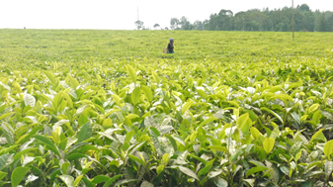 | 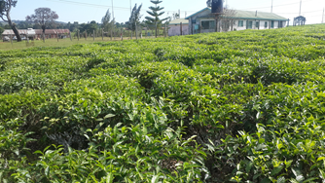
For Details on this trial call: KTC farm Manager: Mr. Mange +255 78 455 4267 or
Dr. Peter Mgimba – MD on +255 75 4596 342

Annex 1E: | Application in Pumpkins


EMTECH FOUNDATION LIMITED
Preliminary Brief Report on the EM Trials to Vegetables
Case of Pumpkins
Date: Sept 2016

Preliminary
A total of Five (5) trials with Two (2) replica were undertaken to measure the impact on the use of EM.1 technology in the growth and production of pumpkins – mainly for the use as vegetables not aiming to produce fruits. The plot settings were as shown in Table 1. The trials took place at the University of Dar es Salaam plots. The plot sizes were 1m x 2 m. Six (6) plants were planted in each plot. The planting of the pumpkins was done on 1st June 2016 and the harvest on 16th July 2016.
Table 13: Set up of the Trials.
Plot # | Trial | Plot # | Trial
1 | Control | 6 | Control
2 | EMAx Bio | 7 | EMAx Bio
3 | Mazao Booster | 8 | Mazao Booster
4 | Mazao Booster+Emax Bio | 9 | Mazao Booster+Emax Bio
5 | Hakika | 10 | Hakika

Explanations:
- Control (CC) = normal cultivation without adding any type of fertilizer.
- EMax (EE) = This is a liquid which is made out of EM.1, also known as extended EM.1 with natural addictive. This addictive was named as EMAXTM Bio Liquid. EMAXTM Bio Liquid is made out of water, EM.1 and other natural food substances. A ratio of 10mls litre of EMAXTM Bio Liquid to 5 litres of clean tape water was applied in an irrigation can.
- Mazao Booster (MB) = Mazao Booster is a type of a fermented material made with EM.1 extended (EMAX Bio Liquid), Molasses and Water. This materials is named as FeedproTM Mazao Booster. 200gms of MB was applied to each plot based on this trial.
- Mazao Booster + EMax (MBEE) = A combination of FeedPro Mazao Bookster and EMAX Bio Liquid on the ratios outlined in each individual treatment.
- Hakika (HK) = This is a compost which is commercially available from the market. The details of the compost are as shown in Table 2. The application was based on 1kg per plot.
During the period of the trial no additional artificial or industrial fertilizer of pesticides were applied.

Results

Descriptive Analysis
Measurement was done on four parameters plants of Pumpkins, after it has been harvested in each plot. Three randomly chosen plants were subject to measurements which included number of leaves, height of the roots and shoots. Weight in Kg was also measured in each of the harvested plot. The descriptive analysis of such measurement is as shown in table 2 and 3 also in figure 1 and 2.
Table 14: Descriptive Analysis of No. of Leaves, Height of Roots and Shoots for the Average Plots
Treatment | N | Minimum | Maximum | Mean | Std. Deviation
CC_NLeaves | 6 | 11.00 | 18.00 | 14.33 | 2.34
EE_NLeaves | 6 | 18.00 | 32.00 | 24.50 | 4.89
MB_NLeaves | 6 | 13.00 | 37.00 | 20.00 | 8.92
MBEE_NLeaves | 6 | 10.00 | 22.00 | 15.17 | 5.00
HK_NLeaves | 6 | 8.00 | 27.00 | 16.17 | 7.76
CC_roots | 6 | 16.00 | 34.00 | 26.50 | 6.50
EE_roots | 6 | 17.00 | 25.00 | 20.67 | 2.73
MB_roots | 6 | 16.00 | 30.00 | 22.17 | 5.91
MBEE_roots | 6 | 16.00 | 40.00 | 24.50 | 8.22
HK_roots | 6 | 13.00 | 43.00 | 27.33 | 11.88
CC_shoots | 6 | 67.00 | 93.00 | 81.00 | 11.37
EE_shoots | 6 | 103.00 | 224.00 | 153.67 | 40.33
MB_shoots | 6 | 47.00 | 120.00 | 89.27 | 30.05
MBEE_shoots | 6 | 68.00 | 174.00 | 116.17 | 51.52
HK_shoots | 6 | 34.00 | 136.00 | 87.50 | 41.95

Leaves: The maximum number of leaves were on the application of Mazao Booster (MB) and EMAx Bio Liquid (EE) recording 37 and 32 leaves respectively. The average mean was on the application of EE and MB recording averages of 24.5±4.89 and 20±8.92 leaves respectively. The details are also observed in Figure 1.
Roots: Maximum number of roots size were for the application of the Hakika (HK) and Mazao Booster and EMAx Bioliquid (MBEE), recording 43cms and 40 cms respectively. Based on average, the sizes were for HK and CC recording means of 27.33±11.88 cms and ±6.50 cms.
Shoots: Maximum number of roots size were for the application of the EE and MBEE with 224 and 174 cms respectively. Based on average, the sizes were for EE and MBEE recording means of 153±40.33 cms and 116.17 ± 51.52 cms.

Figure 1: Average Number of Leaves and Weight of the Pumpkins

Figure 1 and Table 3 presents descriptive analysis of the number of leaves and the number of leaves in each plot size in average based on the five, two replica plots. Table 4 presents the weight and growth based on the Control and the application of EM related products.
Table 15: Summary of the Weight and Number of Leaves of Pumpkins in Various Treatments.
Plot | Treatment | Average | % Change | No Leaves | % Change
1 | Control - Ve | 0.70 |  | 14.33
2 | EMAx Bio | 1.10 | 57.1% | 24.50 | 70.9%
3 | Mazao Booster | 0.60 | -14.3% | 20.00 | 39.5%
4 | Mazao Booster+Emax Bio | 0.95 | 35.7% | 15.17 | 5.8%
5 | Positive Control -Hakika | 0.68 | -3.6% | 16.17 | 12.8%
Maximum average weight was observed in the application of EMAx Bio Liquid (EE) with mean 1.10 kg followed by the application a Mazao Booster and EMAx Bio Liquid (MBEE) with mean of 0.95 kg. It is also noted that the growth of the plant by 26% on the weight and by 39% on the application of EM number of leaves.
Figure 2: Average Weight of the Pumpkins

Further observation on the number of plots has indicated the following as summarized in table 4.
Table 16: On Field Observation of Various Treatment on the Application of EM in Pumpkins plots
Treatment No. | Code | Leaves | Flowers
Control - Ve | CC | Small height leaves | Small flowers not easily visible
EMAx Bio | EE | Flower buds lighted and health green | Average flowers and buds visible
Mazao Booster | MB | Average height leaves | Small flower buds
Mazao Booster + Emax Bio | MBEE | Average height leaves | Flower buds visible
Positive Control -Hakika | HK | Average height leaves | Flower buds visible

From the descriptive statistics the following can be observed:
- There is significant changes in the application of EM.1 technology in form of secondary products in the growth of the plant.

Conclusion and Similar Studies

The results of the trials concludes that there is significant increase in the productivity of the in the application of EM as irrigation to the Pumpkins, harvested for consumption on based on the leaves productivity. There is both an increase in the weight based ono the application of EM as compared to control, as well as height of the leaves.

Appendix I: Raw Data
Treatment/>>Plats | 1 | 2 | 3 | 4 | 5 | 6
CC_shoots | 67 | 71 | 88 | 75 | 93 | 92
CC_roots | 24 | 24 | 34 | 16 | 31 | 30
CC_NLeaves | 11 | 14 | 18 | 15 | 13 | 15
EE_shoots | 138 | 138 | 154 | 103 | 165 | 224
EE_roots | 20 | 21 | 19 | 17 | 25 | 22
EE_NLeaves | 32 | 22 | 18 | 22 | 26 | 27
MB_shoots | 113 | 63 | 47 | 111 | 81.6 | 120
MB_roots | 18 | 27 | 16 | 30 | 17 | 25
MB_NLeaves | 17 | 13 | 13 | 19 | 37 | 21
MBEE_shoots | 164 | 174 | 150 | 69 | 68 | 72
MBEE_roots | 23 | 25 | 16 | 40 | 20 | 23
MBEE_NLeaves | 20 | 22 | 16 | 11 | 12 | 10
HK_shoots | 135 | 93 | 136 | 72 | 55 | 34
HK_roots | 36 | 33 | 43 | 16 | 13 | 23
HK_NLeaves | 27 | 16 | 24 | 12 | 10 | 8

Annex 1F: | Application in Paddy

APPLICATION OF EM.1 TECHNOLOGY IN THE PRODUCTIVITY IN A PADDY FARM
Location: Vianzi Village, Mkuranga District, Pwani. TANZANIA. Season: March – June 2016
Abstract:  A mix of semi decomposed cow manure (2 buckets of 20kg each), field shrubs (1 bucket – about 10kg) was mixed with a liquid solution comprised with 10 litres of water, 150mil of Molasses and 150mil of E.M1 Extended. The mixture and the liquid solution were mixed to an extent that it was neither wet nor dry. The mixture was then kept in airtight non transparent plastic bags and kept in a room temperature with no direct sunlight for a period of 14 days.  After 14 days, the mixture was then packed in 5 kg airtight non transparent plastic bags. Each 5 kgs of the compost manure was then applied in already grown paddy of about three weeks with standby water (see the picture) of a size of about 3 x 10 meters. The application was done spatially, the way a farmer would sow sorghum seeds in a field. For a 30 square meters a farmer would have applied about 50kg of industrial fertilizer and more than 1,000 kgs of raw animal manure.  Extended EM.1 was also used to spray to the paddy crops two times (within the growing cycle) as a fertilizer (booster) to the rice fields. A solution of 1:500 for EM.1 extended and fresh water was applied. Other rice fields were left as control – in fact the farmers don’t use any fertilizer due to the costs and availability of animal manure. |  |  |  |  | 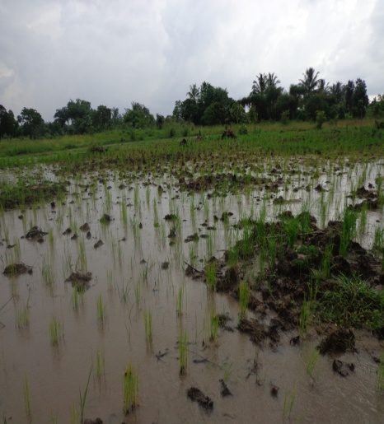
Results: The application to both compost made out of EM.1 and the spraying of Extended EM.1 solution has proved to bring more productivity and lower the cost of fertilizers. It improves sustainably soil fertility and it helps to improve food security in rural areas.
One of the paddy embankments which were applied with manure compost made from EM Compost, only once. The pad stems were on average 9-13 in each seed grown. Further right is the nature of the soil as well as one of the healthy paddy stem – about 20 stems for one seed. | 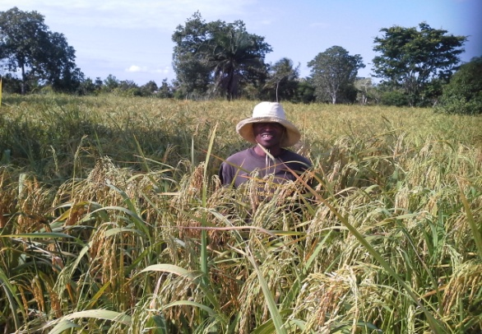 |  |  | 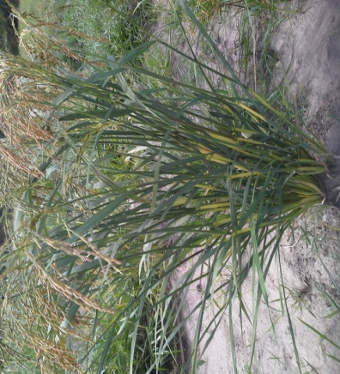
Further Right is one of the Embankments where by EM solution was sprayed. The results were that the stems for each see | 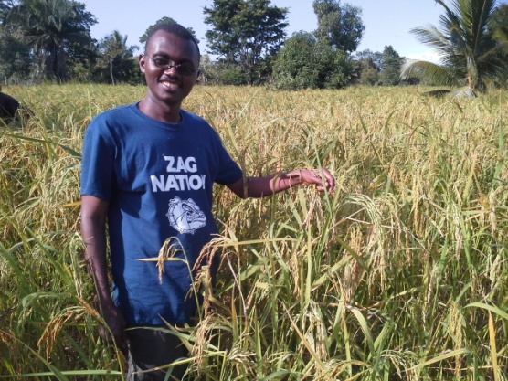 |  | 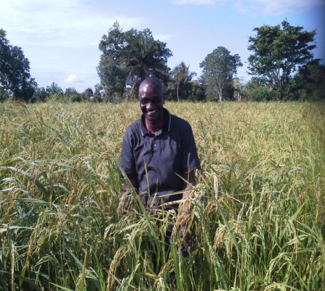
Below is a control rice field grown without application of any fertilizer which is normally the normal growing practice  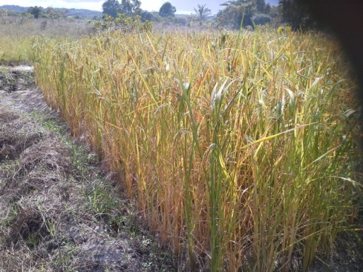 |  | Do you want to hear from the farm owner? Please call: Benedicto Malale: +255 7 75 5099 572  Contact us:  EMTECH FOUNDATION LIMITED  Changanyikeni, Dar es Salaam  P. O. Box 110136, Dar es Salaam  Email: emtanzania@gmail.com  Telephone: +255 75 6446 468 / 075 4300 495

